Part 3

Group By
Similar to SQL GROUP BY clause, PySpark groupBy() transformation that is used to group rows that have the same values in specified columns into summary rows. It allows you to perform aggregate functions on groups of rows, rather than on individual rows, enabling you to summarize data and generate aggregate statistics.

Syntax
DataFrame.groupBy(*cols)/DataFrame.groupby(*cols)
It returns GroupedData object which contains below aggregate functions.
FUNCTION | DEFINITION
count() | Return the number of rows for each group.
max() | Returns the maximum of values for each group.
min() | Returns the minimum of values for each group.
sum() | Returns the total of values for each group.
mean() | Returns the mean of values for each group.
avg() | Returns the average of values for each group.
agg() | Allow to calculate more than one aggregate at a time.
pivot() | This function is used to Pivot the DataFrame.

Creating DataFrame
data = [("James","Sales","NY",90000,34,10000),
("Michael","Sales","NY",86000,56,20000),
("Robert","Sales","CA",81000,30,23000),
("Maria","Finance","CA",90000,24,23000),
("Raman","Finance","CA",99000,40,24000),
("Scott","Finance","NY",83000,36,19000),
("Jen","Finance","NY",79000,53,15000),
("Jeff","Marketing","CA",80000,25,18000),
("Kumar","Marketing","NY",91000,50,21000)
]
# Create DataFrame
columns = ["name","department","state","salary","age","bonus"]
df = spark.createDataFrame(data, columns)
df.printSchema()
df.show()
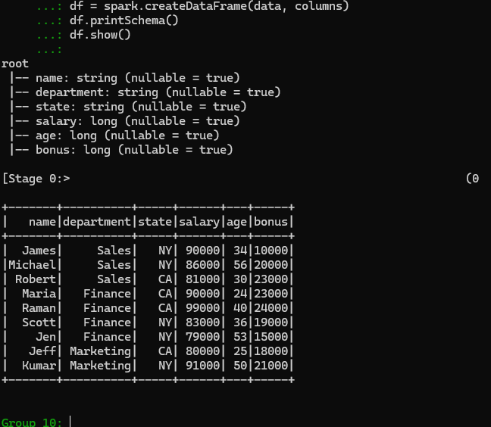

Using aggregate functions
Calculate the number of employees in each department using:
df.groupBy("department").count().show()
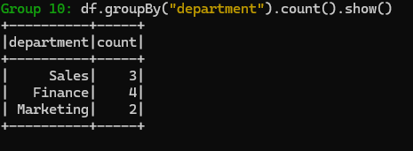
Calculate the sum of salary for each department:
df.groupBy("department").sum("salary").show()
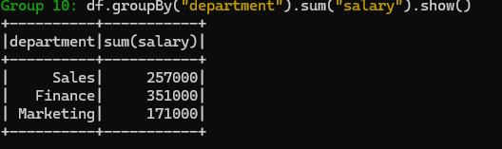
Similarly, calculate the min, max, avg, mean of salary for each department:
df.groupBy("department").min("salary").show()
df.groupBy("department").max("salary").show()
df.groupBy("department").avg("salary").show()
df.groupBy("department").mean("salary").show()
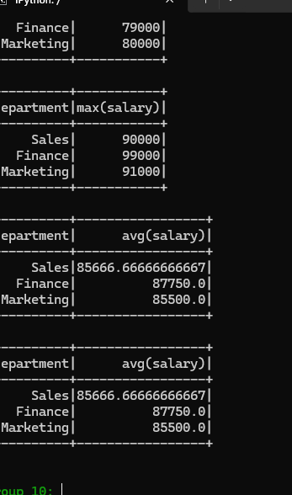

Using multiple columns
Similarly, we can also run groupBy and aggregate on two or more columns, below example does group by on department, state and does sum() on salary and bonus columns.
df.groupBy("department","state") \
.sum("salary","bonus") \
.show()
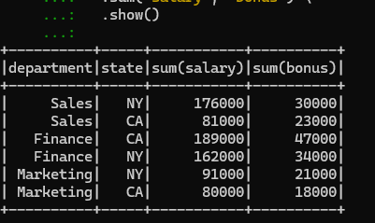

Running more aggregates at a time
Alternatively, you can use groupBy().agg() to perform aggregation on columns after grouping them based on one or more keys.
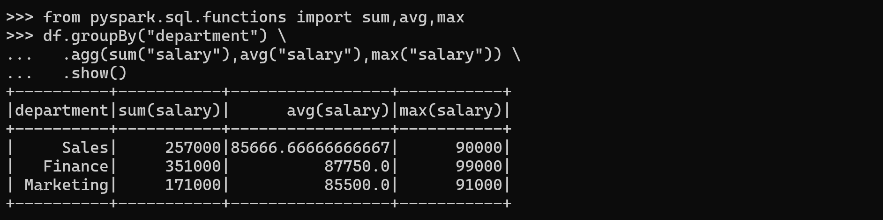
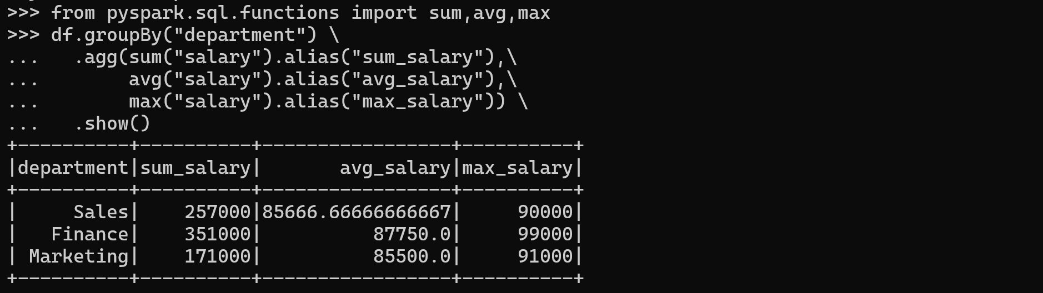

Using filter on aggregated data
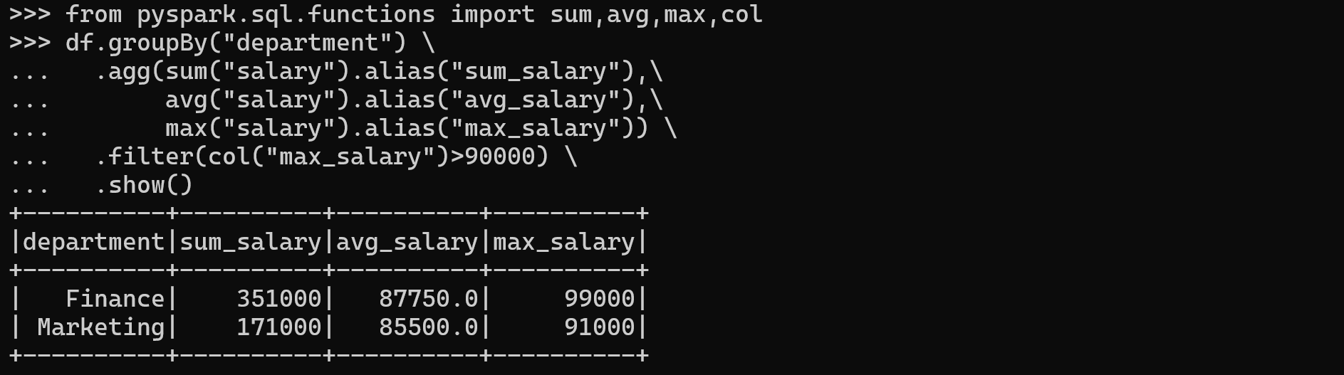

PySpark SQL GROUP BY
# Create a temporary view
df.createOrReplaceTempView("employees")
# Using SQL Query
sql = """
SELECT department,
SUM(salary) AS sum_salary,
AVG(salary) AS avg_salary,
SUM(bonus) AS sum_bonus,
MAX(bonus) AS max_bonus
FROM employees
GROUP BY department
HAVING SUM(bonus) >= 50000"""
# Execute SQL query against the temporary view
spark.sql(sql).show()
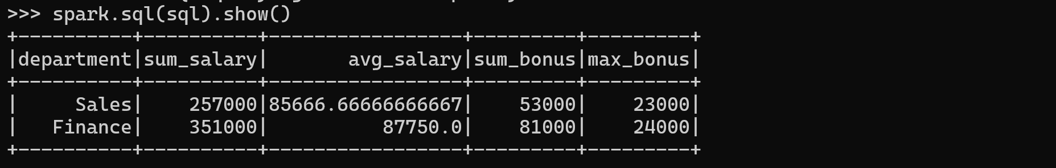

Find the department with the highest total bonus:
# Using SQL Query
sql = """
SELECT department,
SUM(salary) AS sum_salary,
AVG(salary) AS avg_salary,
SUM(bonus) AS sum_bonus,
MAX(bonus) AS max_bonus
FROM employees
GROUP BY department
ORDER BY sum_bonus DESC
LIMIT 1"""
# Execute SQL query against the temporary view
spark.sql(sql).show()
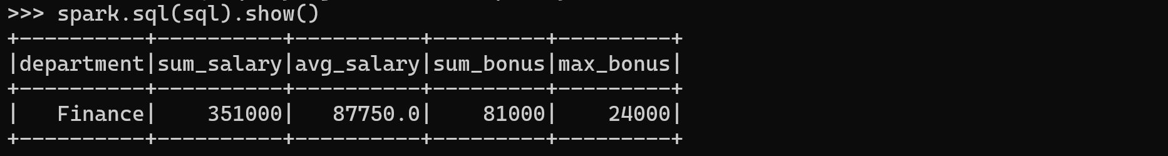
Find the department with the lowest total bonus:
?? 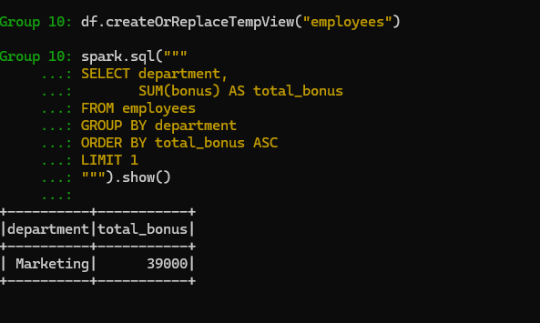

Joining DataFrames
Join is used to combine two DataFrames and by chaining these you can join multiple DataFrames; it supports all basic join type operations available in traditional SQL like INNER, LEFT OUTER, RIGHT OUTER, LEFT ANTI, LEFT SEMI, CROSS, SELF JOIN. Joins are wider transformations that involve data shuffling across the network.

Syntax
join(self, other, on=None, how=None)
Where,
- other: right side of the join
- on: a string for the join condition
- how: default inner. Must be one of inner, cross, outer,full, full_outer, left, left_outer, right, right_outer,left_semi, and left_anti.

Creating DataFrame
emp = [ \
(1,"Smith",-1,"2018","10","M",3000), \
(2,"Rose",1,"2010","20","M",4000), \
(3,"Williams",1,"2010","10","M",1000), \
(4,"Jones",2,"2005","10","F",2000), \
(5,"Brown",2,"2010","40","",-1), \
(6,"Brown",2,"2010","50","",-1) \
]
empColumns = ["emp_id","name","superior_emp_id","year_joined", \
"dept_id","gender","salary"]

empDF = spark.createDataFrame(data=emp, schema = empColumns)
empDF.printSchema()

dept = [ \
("Finance",10), \
("Marketing",20), \
("Sales",30), \
("IT",40) \
]
deptColumns = ["dept_name","dept_id"]
deptDF = spark.createDataFrame(data=dept, schema = deptColumns)
deptDF.printSchema()

empDF.show()
deptDF.show()
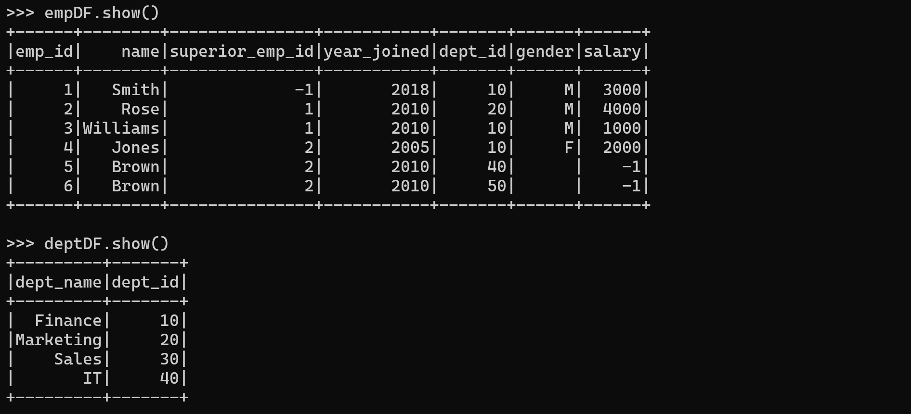

How Join works?
PySpark’s join operation combines data from two or more Datasets based on a common column or key. It is a fundamental operation in PySpark and is similar to SQL joins.

Common Key
In order to join two or more datasets we need a common key or a column on which you want to join. This key is used to join the matching rows from the datasets.

Partitioning
PySpark Datasets are distributed and partitioned across multiple nodes in a cluster. Ideally, data with the same join key should be located in the same partition. If the Datasets are not already partitioned on the join key, PySpark may perform a shuffle operation to redistribute the data, ensuring that rows with the same join key are on the same node. Shuffling can be an expensive operation, especially for large Datasets.

Join Type Specification
We can specify the type of join like inner join, full join, left join, etc., by specifying on “how” parameter of the .join() method. This parameter determines which rows should be included or excluded in the resulting Dataset.

Join Execution
PySpark performs the join by comparing the values in the common key column between the Datasets.

Join Types
Join Type | Description
Inner Join | Returns only the rows with matching keys in both DataFrames.
Left Join | Returns all rows from the left DataFrame and matching rows from the right DataFrame.
Right Join | Returns all rows from the right DataFrame and matching rows from the left DataFrame.
Full Outer Join | Returns all rows from both DataFrames, including matching and non-matching rows.
Left Semi Join | Returns all rows from the left DataFrame where there is a match in the right DataFrame.
Left Anti Join | Returns all rows from the left DataFrame where there is no match in the right DataFrame.

Inner Join
The default join in Spark is the inner join. It returns only the rows with matching keys in both DataFrames.
empDF.show()
deptDF.show()
empDF.join(deptDF, empDF.dept_id == deptDF.dept_id, "inner") \
.show()
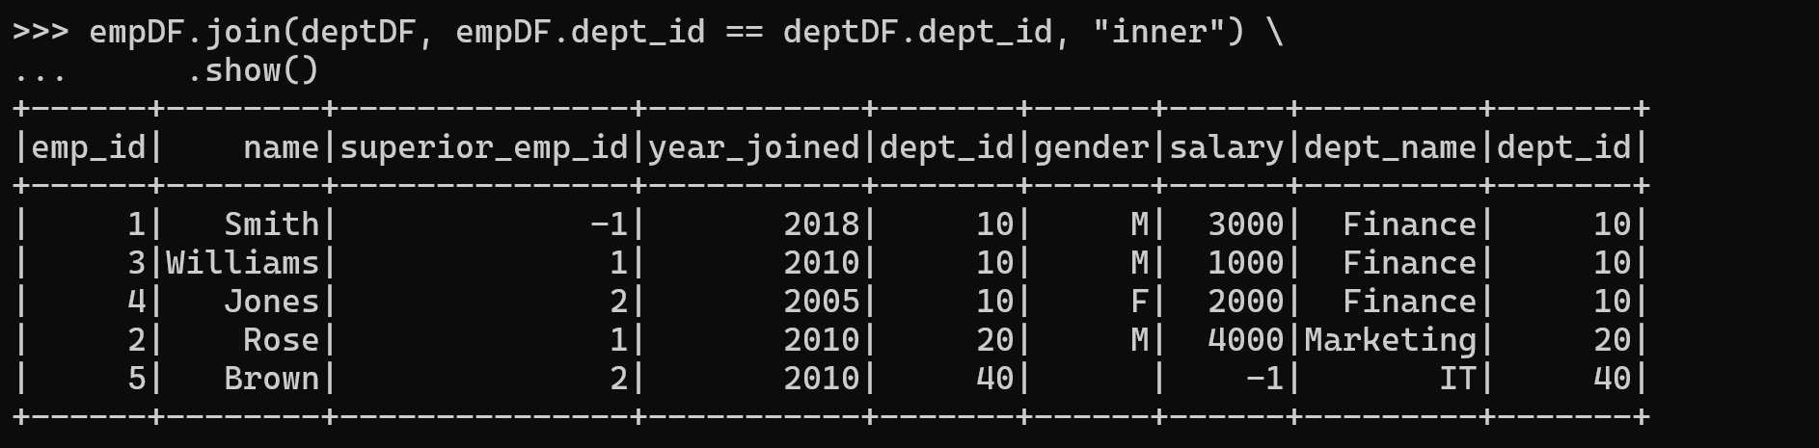

Left Outer Join
Left a.k.a Leftouter join returns all rows from the left dataset regardless of match found on the right dataset when join expression doesn’t match, it assigns null for that record and drops records from right where match not found.
empDF.show()
deptDF.show()
empDF.join(deptDF,empDF. dept_id == deptDF.dept_id,"left") \
.show()
empDF.join(deptDF,empDF. dept_id == deptDF.dept_id,"leftouter") \
.show()
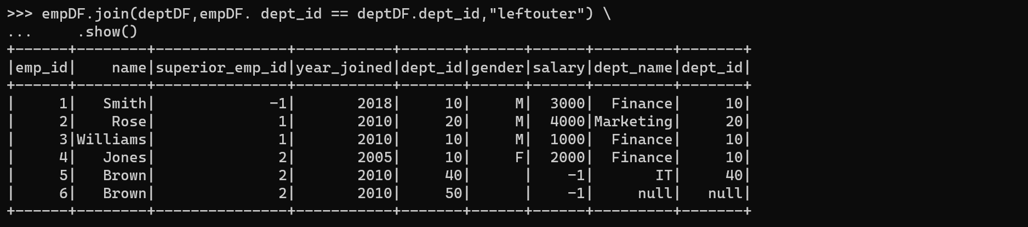

Right Outer Join
Right a.k.a Rightouter join is opposite of left join, here it returns all rows from the right dataset regardless of math found on the left dataset, when join expression doesn’t match, it assigns null for that record and drops records from left where match not found.
empDF.show()
deptDF.show()
empDF.join(deptDF,empDF.dept_id == deptDF.dept_id,"right") \
.show()
empDF.join(deptDF,empDF.dept_id == deptDF.dept_id,"rightouter") \
.show()
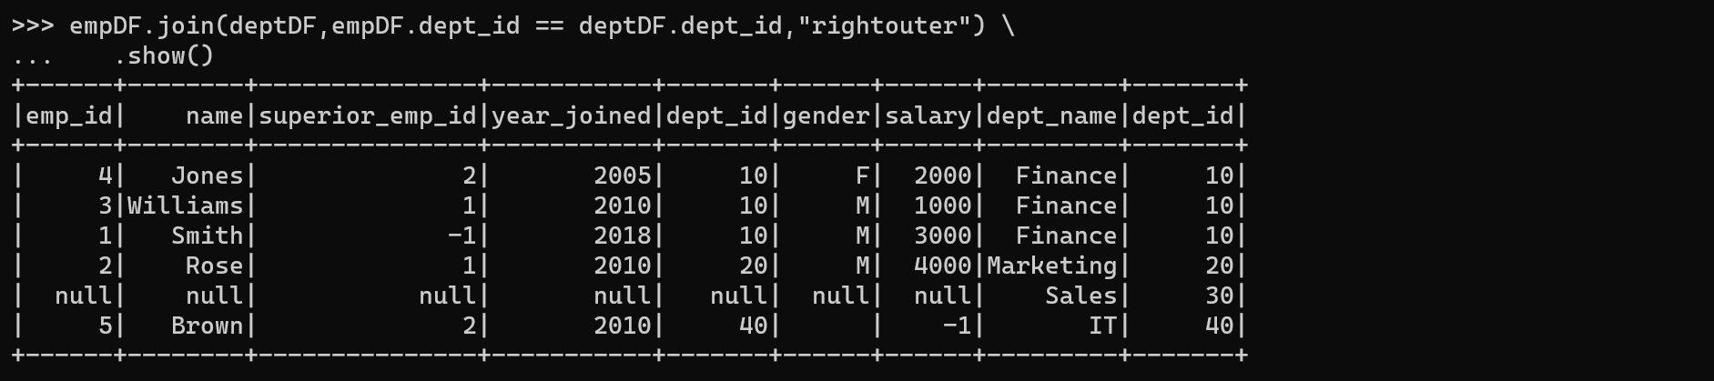

Full Outer Join
Outer a.k.a full, fullouter join in PySpark combines the results of both left and right outer joins, ensuring that all records from both DataFrames are included in the resulting DataFrame. It includes all rows from both DataFrames and fills in missing values with nulls where there is no match. In other words, it merges the DataFrames based on a common key, but retains all rows from both DataFrames, even if there’s no match. This join type is useful when you want to preserve all the information from both datasets, regardless of whether there’s a match on the key or not.
empDF.show()
deptDF.show()
empDF.join(deptDF,empDF. dept_id == deptDF.dept_id,"outer").show()
empDF.join(deptDF,empDF. dept_id == deptDF.dept_id,"full") .show()
empDF.join(deptDF,empDF. dept_id == deptDF.dept_id,"fullouter").show()
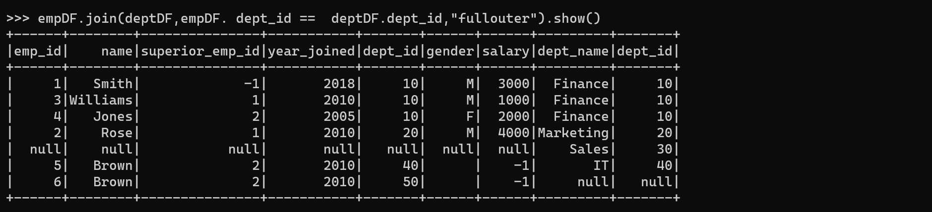

Left Semi Join
A Left Semi Join in PySpark returns only the rows from the left DataFrame where there is a match with the right DataFrame. It does not include any columns from the right DataFrame in the resulting DataFrame. This join type is useful when you only want to filter rows from the left DataFrame based on whether they have a matching key in the right DataFrame.
Left Semi Join can also be achieved by selecting only the columns from the left dataset from the result of the inner join
empDF.show()
deptDF.show()
empDF.join(deptDF,empDF. dept_id == deptDF.dept_id,"leftsemi").show()
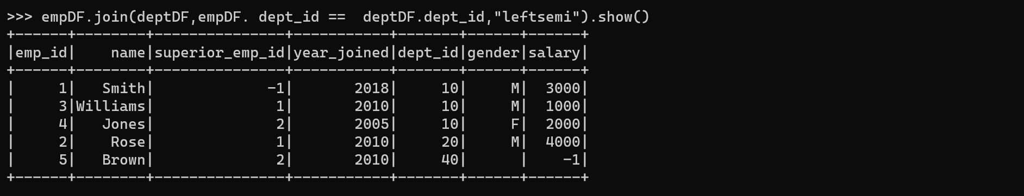

Left Anti Join
A Left Anti Join in PySpark returns only the rows from the left DataFrame where there is no match with the right DataFrame. It excludes any rows from the left DataFrame that have a corresponding key in the right DataFrame. This join type is useful when you want to filter out rows from the left DataFrame that have matching keys in the right DataFrame.
empDF.show()
deptDF.show()
empDF.join(deptDF,empDF.dept_id == deptDF.dept_id,"leftanti").show()
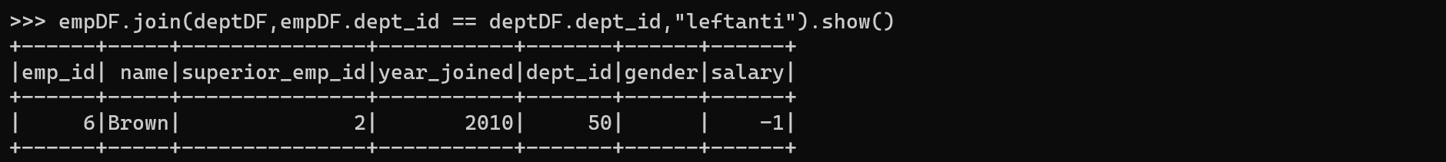

Self Join
Joins are not complete without a self join. We can use any of the above-explained join types to join DataFrame to itself. Below example use inner self join.
empDF.alias("emp1").join(empDF.alias("emp2"), \
col("emp1.superior_emp_id") == col("emp2.emp_id"),"inner") \
.select(col("emp1.emp_id"),col("emp1.name"), \
col("emp2.emp_id").alias("superior_emp_id"), \
col("emp2.name").alias("superior_emp_name")) \
.show()
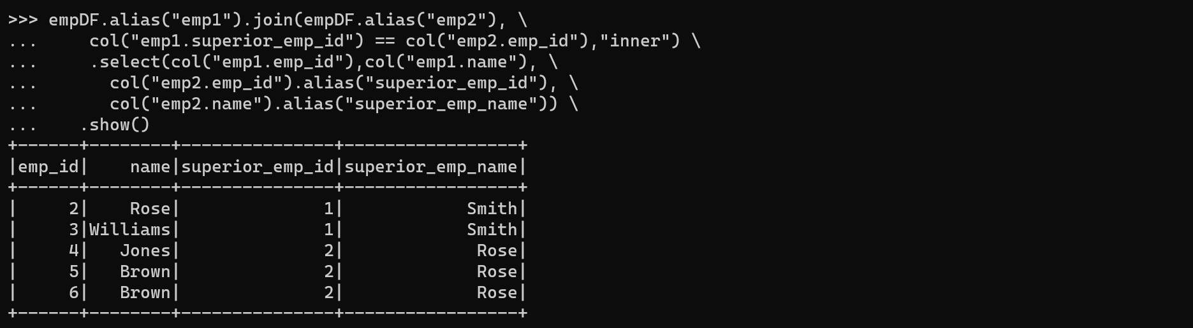

PySpark SQL Join
Alternatively, you can also use SQL query to join DataFrames/tables in PySpark. To do so, first, create a temporary view using createOrReplaceTempView(), then use the spark.sql() to execute the join query.
empDF.createOrReplaceTempView("EMP")
deptDF.createOrReplaceTempView("DEPT")
joinDF1 = spark.sql("select * from EMP e, DEPT d where e.dept_id == d.dept_id") \
.show()
joinDF2 = spark.sql("select * from EMP e INNER JOIN DEPT d ON e.dept_id == d.dept_id") \
.show()
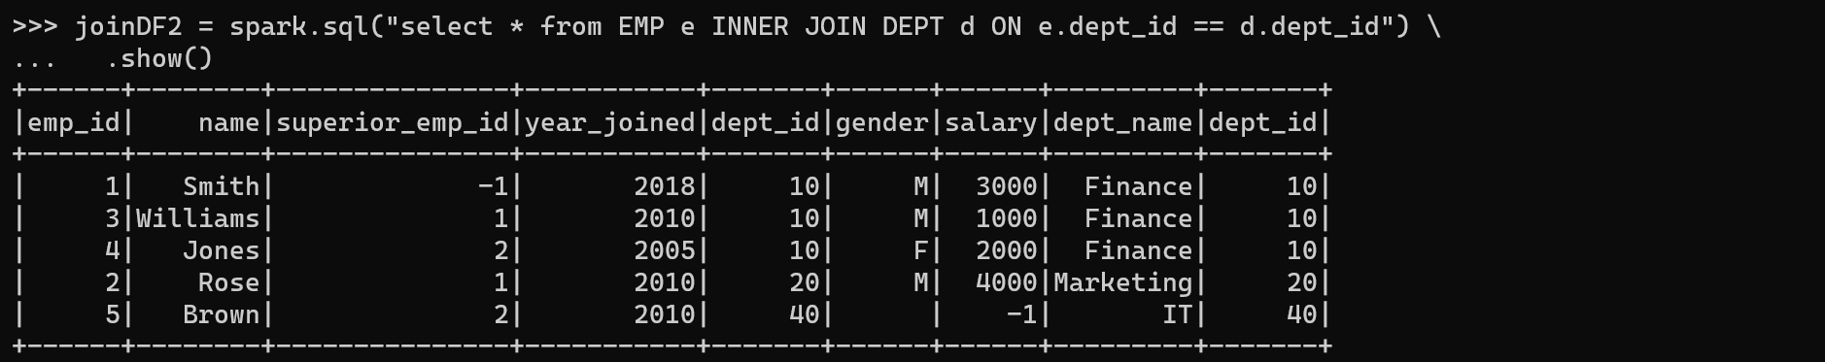

Join on multiple DataFrames
When you need to join more than two tables, you either use SQL expression after creating a temporary view on the DataFrame or use the result of join operation to join with another DataFrame like chaining them.
df1.join(df2,df1.id1 == df2.id2,"inner") \
.join(df3,df1.id1 == df3.id3,"inner")

Pivot and Unpivot DataFrame
The pivot() function is used to rotate/transpose the data from one column into multiple columns and back using unpivot().

Syntax
pivot_df = original_df.groupBy("grouping_column")
.pivot("pivot_column")
.agg({"agg_column": "agg_function"})
Where,
- grouping_column: The column used for grouping.
- pivot_column: The column whose distinct values become new columns.
- agg_column: The column for which aggregation is applied (e.g., using a function like sum, avg, etc.).

Creating DataFrame
data = [("Banana",1000,"USA"), ("Carrots",1500,"USA"), ("Beans",1600,"USA"), \
("Orange",2000,"USA"),("Orange",2000,"USA"),("Banana",400,"China"), \
("Carrots",1200,"China"),("Beans",1500,"China"),("Orange",4000,"China"), \
("Banana",2000,"Canada"),("Carrots",2000,"Canada"),("Beans",2000,"Mexico")]
columns= ["Product","Amount","Country"]
df = spark.createDataFrame(data, columns)
df.printSchema()
df.show()
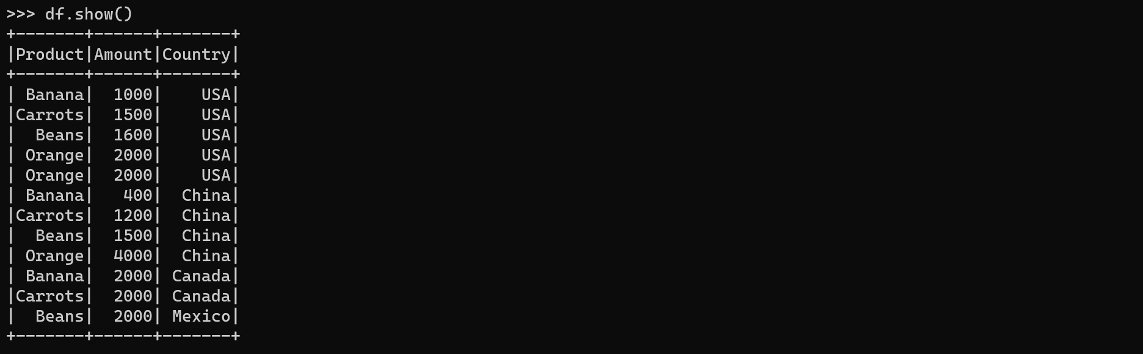

Pivot DataFrame
To get the total amount exported to each country of each product, will do group by Product, pivot by Country, and the sum of Amount.
Normal method:
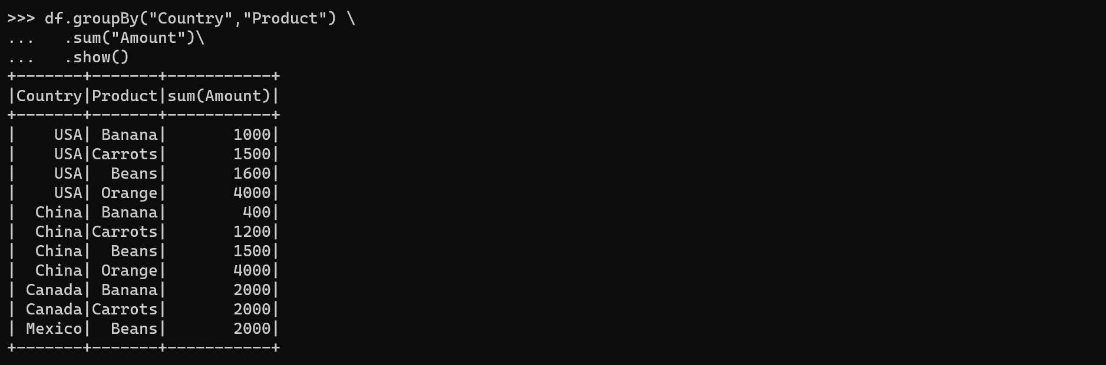
Using pivot:
pivotDF = df.groupBy("Product")\
.pivot("Country")\
.sum("Amount")
pivotDF.printSchema()
pivotDF.show()
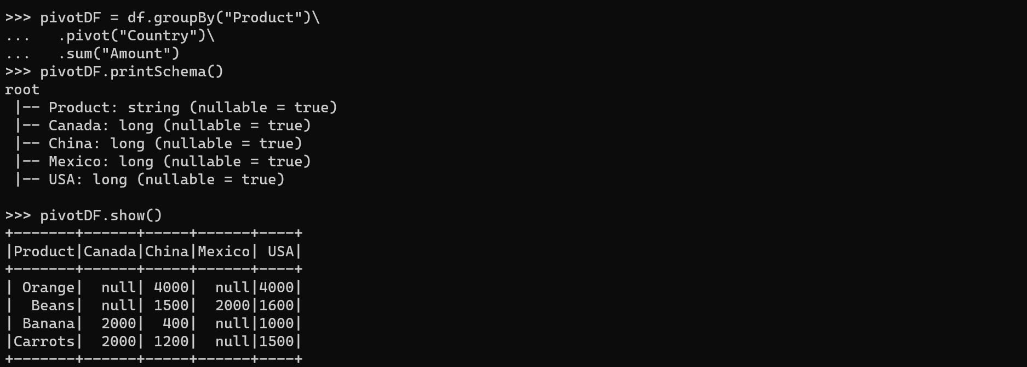
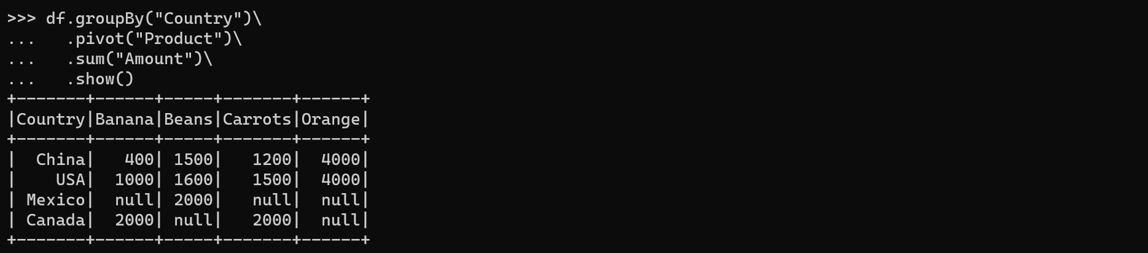

Unpivot DataFrame
Unpivot is a reverse operation, we can achieve by rotating column values into rows values. PySpark SQL doesn’t have unpivot function hence will use the stack() function. Below code converts column countries to row.
from pyspark.sql.functions import expr
unpivotExpr = "stack(3, 'Canada', Canada, 'China', China, 'Mexico', Mexico) as (Country,Total)"
unPivotDF = pivotDF.select("Product",expr(unpivotExpr))unPivotDF.show()
